«Holidays are coming. Are you ready?»
Motto:
«Just Enjoy your Summer»

Day 1

A Good Start for Summer Holidays | - Минутка Здоровья | https://yandex.ru/video/preview/?filmId=5516967177606211643&from=tabbar&reqid=1591276414815036-658630256310337227300109-sas1-6052&suggest_reqid=412215767156303435764168336332219&text=morning+exercises+for+teens | 8.45 – 9.00
 | - Breakfast on the Beach |  | 9.00 - 9.30
 | - Here We Go!Let's Dive after the Summer  - Wanna talk about Summer?? | https://www.liveworksheets.com/worksheets/en/English_as_a_Second_Language_(ESL)/Travel_and_tourism/Holidays_listening_qq18376hu  https://skyteach.ru/wp-content/uploads/2018/06/Summer-Activitiesworksheet.pdf | 9.45 -13.00
 | - Lunch in the Shade |  | 13.00 -13.30
 | - Holiday Activities (игра - онлайн) | https://learnenglishkids.britishcouncil.org/word-games/holiday-activities | 13.30 -14.30
Day 2

What to take and where to go? | - Morning exercises | https://yandex.ru/video/preview/?filmId=5516967177606211643&from=tabbar&reqid=1591276414815036-658630256310337227300109-sas1-6052&suggest_reqid=412215767156303435764168336332219&text=morning+exercises+for+teens | 8.45 – 9.00
 | - Breakfast in the café |  | 9.00 –  9.30
 | - Holidays in Britain. What to Choose? | https://learnenglishteens.britishcouncil.org/ar/uk-now/read-uk/holidays | 9.45 -13.00
 | - Lunch |  | 13.00 -13.30
 | - Are you ready for the trip? | https://learnenglishteens.britishcouncil.org/vocabulary/beginner-vocabulary/holidays | 13.30 -14.30
Day 3

How to order food | - Summer Music | https://www.billboard.com/charts/world-albums | 8.45 – 9.00
 | - Breakfast in the hotel |  | 9.00 –  9.30
 | - Ordering Food and Drinks | https://learnenglishteens.britishcouncil.org/skills/listening/beginner-a1-listening/ordering-food-cafe | 9.45 -13.00
 | - A Restaurant Menu | https://learnenglishteens.britishcouncil.org/skills/reading/elementary-a2-reading/restaurant-menu
 | - Lunch |  | 13.00 -13.30
 | Watching «Ordering from a restaurant - Episode 5» | https://www.britishcouncil.my/english/courses-adults/learning-tips/video-tip/ordering-from-restaurant | 13.30 -14.30
 | - Speaking Club. Practice | online
Day 4

Christmas in Australia | - Morning exercises | Playing fav music online | 8.45 – 9.00
 | - Surf and Breakfast |  | 9.00 –  9.30
 | - Listening to Mrs Claus explaining Christmas Traditions | https://learnenglishkids.britishcouncil.org/es/video-zone/mrs-claus-explains-christmas-traditions | 9.45 -13.00
 | - Lunch |  | 13.00 -13.30
 | - Speaking Club. «5-reasons-to-love-christmas-in-australia» | https://ielts.com.au/articles/5-reasons-to-love-christmas-in-australia/ | 13.30 -14.30
 | - Some facts about Australia. Sightseeing | https://www.liveworksheets.com/qd195765bs
Day 5

«A trip. How not to get lost» | 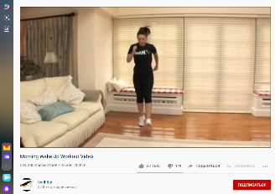  - Мorning exercises | https://www.youtube.com/watch?time_continue=3&v=q7dXzmPwCQs&feature=emb_logo | 8.45 – 9.00
 | - Breakfast | https://www.youtube.com/watch?v=IE50VzCkVLk&feature=emb_logo | 9.00 –  9.30
 | 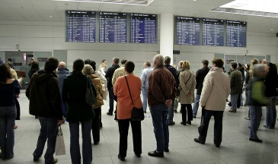  - Trains and Travel. Practice | https://learnenglishteens.britishcouncil.org/skills/listening/elementary-a2-listening/trains-travel | 9.45 -13.00
 | - Travelling on Holiday Abroad | https://learnenglishteens.britishcouncil.org/skills/listening/elementary-a2-listening/travelling-abroad
 | - Travelling abroad. E-mail | https://learnenglishteens.britishcouncil.org/skills/writing/elementary-a2-writing/travelling-abroad
 | - Lunch |  | 13.00 -13.30
 | - Tickets. Speaking Club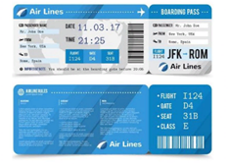 | https://www.liveworksheets.com/worksheets/en/English_as_a_Second_Language_(ESL)/At_the_airport/Travel_me36424ok | 13.30 -14.30

